AI ASSISTED CODING
END LAB EXAM
2403A53056
BATCH:18
SET-1
Q:1Your company is developing an AI-based receipt analyzer. Write a prompt that instructs the AI to generate a Python script that extracts:
- store name
- purchase date
- total payable amount
Refine the prompt to improve extraction reliability.
(Ensure the generated script includes docstrings, comments, and unit tests.)
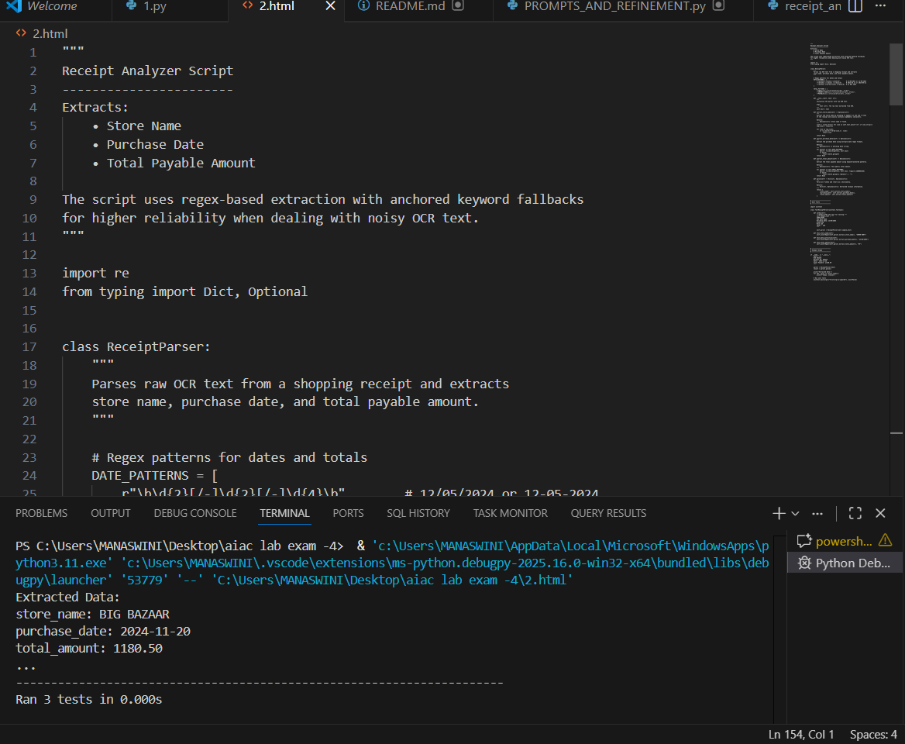
Q:2
